HANOI UNIVERSITY OF SCIENCE AND TECHNOLOGY

School of Information and communications technology

Software Requirement Specification

Lab 03

Nguyễn Đình Hồng Phong

Table of contents

Table of contents 1

1 Introduction 2

1.1 Objective 2

1.2 Scope 2

1.3 Glossary 2

1.4 References 3

2 Overall Description 4

2.1 Survey 4

2.2 Overall requirements 4

2.3 Business process 4

3 Detailed Requirements 5

3.1 Use case 1 6

3.2 Use case 2 7

4 Supplementary specification 8

4.1 Functionality 8

4.2 Usability 8

4.3 Reliability 8

4.4 Performance 8

4.5 Supportability 8

4.6 Other requirements 8

# Introduction

## Objective

* AIMS Project is a desktop e-commerce software designed for round-the-clock operation, allowing new users to easily familiarize themselves.

## Scope

* This software can serve up to 1,000 customers simultaneously without significantly reducing performance and can operate continuously for 300 hours without failure. Additionally, the software can resume normal operation within a maximum of 1 hour after an incident. The maximum response time of the software is 2 seconds under normal conditions or 5 seconds during peak hours.
* Users can register to create an account for themselves, then log in to use the functions of the system. Users can log in using their system account, or log in using their Facebook account. Any user can update their personal information. When a user forgets their password, they can request the system to allow them to reset their password via a link with a token sent to the registered email.
* The administrator can disable a user account, or require the user to change their password at a certain time or periodically. The administrator can assign user roles to users. A user can have multiple roles in the software. Each user role is set up to be able to use certain functions. Each function can be used by multiple user roles. Whenever a new function is added, the administrator needs to enter information about this function into the software for management. After a user successfully logs in, depending on the user roles they have, the software will automatically create a menu containing the functions that those user roles are allowed to use. Whenever the user selects a function on the menu, the interface corresponding to the function will be displayed.

## Glossary

| ***No*** | ***Term*** | ***Explanation*** | ***Example*** | ***Note*** |
| --- | --- | --- | --- | --- |
| 1 | CRUD | The four primary operations on an object : Create, Read, Update, and Delete. |  |  |
| 2 | Administrator | A team of individuals tasked with management responsibilities. |  |  |

## References

# Overall Description

## Survey

* There are 4 actors in this software : customer, product manager, administrator and VNPay. The customer is the normal user who access the system to purchase products. The product manager holds the reins of their shop, overseeing its administration. The admin can manage all system, change role of user. VNPay operates as a third-party facilitator, support the payment process for customers.

## Overall requirements

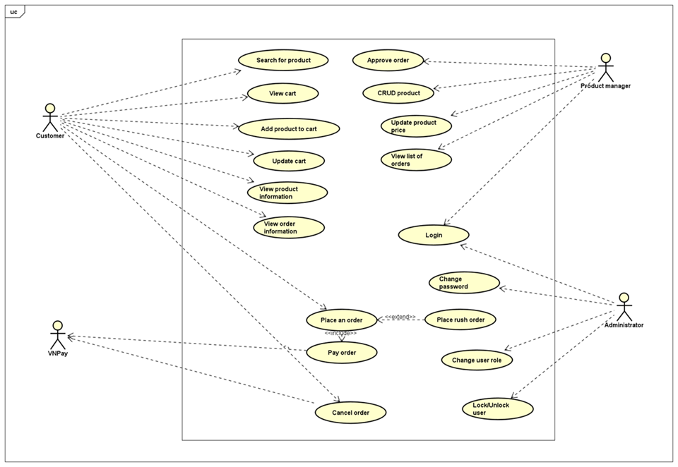

## Business process

* **The process of placing an order as a customer** : Firstly, the customer selects the desired products they wish to purchase. Once they have made their selections, they proceed to request placing the order in the cart. At this stage, the AIMS software steps in to verify the availability of the chosen products in the cart.Following this, the AIMS software displays a form for the customer to input their delivery information along with the order details. This information is then submitted by the customer. Once the delivery information is received, the AIMS software proceeds to calculate and display the total order cost, including shipping fees. The customer is then prompted to proceed with payment for the order. Upon the customer's request to pay the order, the AIMS software initiates the "Pay order" use case, facilitating the creation of a new order. Subsequently, the software empties the cart to prepare for new transactions. Following the successful completion of the transaction, the AIMS software sends an email notification containing order details and information to the customer, ensuring transparency and communication throughout the process. Finally, the software displays a confirmation message to the customer, providing them with details of the successful order, as well as transaction information. This step concludes the ordering process, ensuring a seamless experience for the customer from start to finish.

* **The process of placing a rush order as a customer** : Initially, customers are provided with the option to select rush order delivery, indicating their urgency for the delivery of their purchases. Following this, the AIMS software undertakes a crucial verification process to determine whether the specified delivery addresses fall within the inner city limits of Hanoi. Once the addresses are confirmed, the software proceeds to assess the eligibility of the selected products for rush delivery. Subsequently, the AIMS software prompts customers to review and potentially update their delivery information or method. The AIMS software undertakes these calculations meticulously, reflecting any adjustments required for rush order delivery accurately. With the recalculated fees and invoice updates in place, customers proceed seamlessly to the next step in the ordering process. The customer proceeds to Use Case “Place Order” to continue.

* **The process of paying for an order as a customer** : The initiation of the payment process as the AIMS software transitions to the checkout process. Following this, the AIMS software redirects customers to VNPay, a trusted payment gateway, providing them with essential payment information. Customers with the freedom to select their preferred payment method from the options provided by VNPay. Upon selecting a payment method, VNPay displays a form for customers to fill out. This form captures essential payment information required to process the transaction securely and efficiently. Customer's active participation in the payment process as they provide the necessary information requested by VNPay. With the information provided, VNPay prompting the customer to verify their information and authorize the payment. Upon receiving authorization, the customer confirming the payment, signifying the completion of the transaction process. Subsequently, VNPay notifies the transaction result and redirects customers back to the AIMS software. The AIMS software diligently saves the payment transaction, capturing essential details for record-keeping and future reference.

# Detailed Requirements

## Use case 1

|  |  |  |  |  |  |  |  |  |  |  |  |  |  |  |  |  |  |  |  |  |  |  |  |  |  |  |  |  |  |  |  |  |  |  |  |  |  |  |  |  |  |  |  |  |  |  |  |  |  |  |  |  |  |  |  |  |  |  |  |  |  |  |  |  |  |  |  |  |
| --- | --- | --- | --- | --- | --- | --- | --- | --- | --- | --- | --- | --- | --- | --- | --- | --- | --- | --- | --- | --- | --- | --- | --- | --- | --- | --- | --- | --- | --- | --- | --- | --- | --- | --- | --- | --- | --- | --- | --- | --- | --- | --- | --- | --- | --- | --- | --- | --- | --- | --- | --- | --- | --- | --- | --- | --- | --- | --- | --- | --- | --- | --- | --- | --- | --- | --- | --- | --- |
| 1. **Use case code**   UC002   1. **Brief Description**   This use case describes the interaction between Customer and AIMS System when Customer wishes to place an rush order with the confirmed items.   1. **Actors**  * Customer  1. **Preconditions**  * Customer has already selected products * Customer has completed the delivery information  1. **Basic Flow of Events**  * Step 1: Customer selects rush order delivery * Step 2 : The AIMS software verifies whether addresses are located within the inner city of Hanoi or not * Step 3 : The AIMS software checks product eligibility * Step 4 : The AIMS software prompts the customer to update the delivery information or delivery method (See Table 1) * Step 5 : Customer completes all procedure that software request * Step 6: The AIMS software recalculates the delivery fees and updates the corresponding invoice (See Table 2) * Step 7: The customer proceeds to Step 8 – Use Case “Place Order”  1. **Alternative flows**  |  |  |  |  |  | | --- | --- | --- | --- | --- | | **No** | **Location** | **Condition** | **Action** | **Resume location** | | 1 | At step 2 | If address does not support rush order | AIMS Software notifies and requests customer to update address | Resume at step 1 | | 2 | At step 3 | If no product is eligible for rush delivery | AIMS Software notifies the and requests customer to update cart | Resume at step 5 |  1. **Input data**   **Table 1**   |  |  |  |  |  |  | | --- | --- | --- | --- | --- | --- | | **No** | **Data fields** | **Description** | **Mandatory** | **Valid condition** | **Example** | | 1 | Delivery Time | Time for delivery follow format “dd/mm/yyyy hh:mm” | Yes | hh from 6 to 22  mm from 0 to 59  dd/mm/yyyy must be valid date | 20/03/2024 17:30 | | 2 | Delivery note | String | Yes | String with minimum length of 5 characters | Ship to my company |      1. **Output data**   **Table 2**   |  |  |  |  |  | | --- | --- | --- | --- | --- | | **No** | **Data fields** | **Description** | **Display format** | **Example** | | 1 | Product Name | Name of product | String | Book | | 2 | Rush delivery availability | Check whether rush delivery is eligible or not | True if rush delivery is eligible or False otherwise | False | | 3 | Price of products |  | Positive number denominated in VND with “,” delimiter | 100,000 VND | | 4 | Fee for rush delivery | If rush delivery is eligible, determine fee for rush delivery | 0 if rush delivery is unavailable, otherwise  Positive number denominated in VND with “,” delimiter | 0  50,000 VND | | 5 | Fee for normal delivery | If rush delivery is ineligible, determine fee for normal delivery | 0 if rush delivery is available, otherwise  Positive number denominated in VND with “,” delimiter | 0  40,000 VND | | 6 | Total fee | Total amount for products and delivery | Positive number denominated in VND with “,” delimiter | 350,000 VND |  1. **Postconditions**  * AIMS System sends information about rush delivery order to Customer   Customer can see notice from AIMS System |

## Use case 2

|  |
| --- |
| **Use Case “Place rush order”** |
| 1. **Use case code**   UC002   1. **Brief Description**   This use case describes the interaction between Customer and AIMS System when Customer wishes to place an rush order with the confirmed items.   1. **Actors**  * Customer  1. **Preconditions**  * Customer has already selected products * Customer has completed the delivery information  1. **Basic Flow of Events**  * Step 1: Customer selects rush order delivery * Step 2 : The AIMS software verifies whether addresses are located within the inner city of Hanoi or not * Step 3 : The AIMS software checks product eligibility * Step 4 : The AIMS software prompts the customer to update the delivery information or delivery method (See Table 1) * Step 5 : Customer completes all procedure that software request * Step 6: The AIMS software recalculates the delivery fees and updates the corresponding invoice (See Table 2) * Step 7: The customer proceeds to Step 8 – Use Case “Place Order”  1. **Alternative flows**  |  |  |  |  |  | | --- | --- | --- | --- | --- | | **No** | **Location** | **Condition** | **Action** | **Resume location** | | 1 | At step 2 | If address does not support rush order | AIMS Software notifies and requests customer to update address | Resume at step 1 | | 2 | At step 3 | If no product is eligible for rush delivery | AIMS Software notifies the and requests customer to update cart | Resume at step 5 |  1. **Input data**   **Table 1**   |  |  |  |  |  |  | | --- | --- | --- | --- | --- | --- | | **No** | **Data fields** | **Description** | **Mandatory** | **Valid condition** | **Example** | | 1 | Delivery Time | Time for delivery follow format “dd/mm/yyyy hh:mm” | Yes | hh from 6 to 22  mm from 0 to 59  dd/mm/yyyy must be valid date | 20/03/2024 17:30 | | 2 | Delivery note | String | Yes | String with minimum length of 5 characters | Ship to my company |      1. **Output data**   **Table 2**   |  |  |  |  |  | | --- | --- | --- | --- | --- | | **No** | **Data fields** | **Description** | **Display format** | **Example** | | 1 | Product Name | Name of product | String | Book | | 2 | Rush delivery availability | Check whether rush delivery is eligible or not | True if rush delivery is eligible or False otherwise | False | | 3 | Price of products |  | Positive number denominated in VND with “,” delimiter | 100,000 VND | | 4 | Fee for rush delivery | If rush delivery is eligible, determine fee for rush delivery | 0 if rush delivery is unavailable, otherwise  Positive number denominated in VND with “,” delimiter | 0  50,000 VND | | 5 | Fee for normal delivery | If rush delivery is ineligible, determine fee for normal delivery | 0 if rush delivery is available, otherwise  Positive number denominated in VND with “,” delimiter | 0  40,000 VND | | 6 | Total fee | Total amount for products and delivery | Positive number denominated in VND with “,” delimiter | 350,000 VND |  1. **Postconditions**  * AIMS System sends information about rush delivery order to Customer * Customer can see notice from AIMS System |

## Use case 3

|  |
| --- |
| **Use Case “Pay order”** |
| 1. **Use case code**  * UC003  1. **Brief Description**  * This use case describes the interaction between Customer and AIMS System when Customer wishes to pay order before finishing place an order.  1. **Actors**  * Customer * AIMS System * VNPay  1. **Preconditions**  * Customer has already furnished delivery information(or rush delivery).  1. **Basic Flow of Events**  * Step 1 : The AIMS software shifts to checkout process (See Table 2) * Step 2 : The AIMS software redirects to VNPay with payment information * Step 3 : Customer selects a payment method * Step 4 : VNPay displays a form for customers to fill out (See Table 1) * Step 5 : Customer provides the necessary information * Step 6 : VNPay asks the customer to verify their information and authorize the payment * Step 7 : Customer confirms the payment * Step 8 : VNPay notifies the transaction result and redirects to AIMS software * Step 9 : AIMS software saves the payment transaction  1. **Alternative flows**  |  |  |  |  |  | | --- | --- | --- | --- | --- | | **No** | **Location** | **Condition** | **Action** | **Resume location** | | 1 | At step 7 | If customer does not confirm payment or they can not afford payment | VNPay redirects to AIMS software | Resume at step 1 |  1. **Input data**   **Table 1**   |  |  |  |  |  |  | | --- | --- | --- | --- | --- | --- | | **No** | **Data fields** | **Description** | **Mandatory** | **Valid condition** | **Example** | | 1 | Phone number |  | Yes |  | 0358337038 |      1. **Output data**   **Table 2**   |  |  |  |  |  | | --- | --- | --- | --- | --- | | **No** | **Data fields** | **Description** | **Display format** | **Example** | | 1 | Product Name | Name of product | String | Book | | 2 | Price | Price of the corresponding media product | Positive number denominated in VND with “,” delimiter | 100,000 VND | | 3 | Quantity | Quantity of the corresponding media | Positive integer number | 4 | | 4 | Amount | Total money of the corresponding media | Positive number denominated in VND with “,” delimiter | 750,000 VND | | 5 | Subtotal Before VAT | Total price of products in the cart before VAT | Positive number denominated in VND with “,” delimiter | 350,000 VND | | 6 | Subtotal | Total price of products in the cart before VAT | Positive number denominated in VND with “,” delimiter | 375,000 VND | | 7 | Shipping fees |  | Positive number denominated in VND with “,” delimiter | 50,000 VND | | 8 | Total | Sum of subtotal and shipping fees | Positive number denominated in VND with “,” delimiter | 425,000 VND | | 9 | Name |  |  | Nguyễn Đình Hồng Phong | | 10 | Phone number |  |  | 0358337038 | | 11 | Province |  |  | Bắc Ninh | | 12 | Address |  |  | Khu phố Rích Gạo, Phù Chẩn, Thành phố Từ Sơn, Bắc Ninh | | 13 | Shipping instructions |  |  | Ship to my house |  1. **Postconditions**  * Customer’s available online balance exceeds the total fees |

# Supplementary specification

## Functionality

* The AIMS Project functions as a desktop e-commerce application, guaranteeing continuous operation and facilitating smooth introduction for inexperienced users.

## Usability

* The software is designed with user-friendliness in mind, allowing new users to easily familiarize themselves with its features and capabilities.

## Reliability

* AIMS demonstrates exceptional reliability, capable of accommodating up to 1,000 concurrent customers without experiencing notable performance decline. It boasts continuous operation for up to 300 hours without interruption, and in the event of an incident, it can resume normal functionality within a maximum of 1 hour.

## Performance

* Under regular conditions, the software consistently maintains a maximum response time of 2 seconds. Additionally, it is equipped to manage peak loads, ensuring efficient performance even during periods of high traffic, with a maximum response time of 5 seconds.

## Supportability

* The AIMS platform is backed by a robust technical infrastructure, facilitating easy maintenance and updates. This ensures uninterrupted service and enables the platform to adapt seamlessly to evolving requirements.

## Other requirements

* Additional requirements encompass the integration capabilities with the VNPay payment gateway service.